
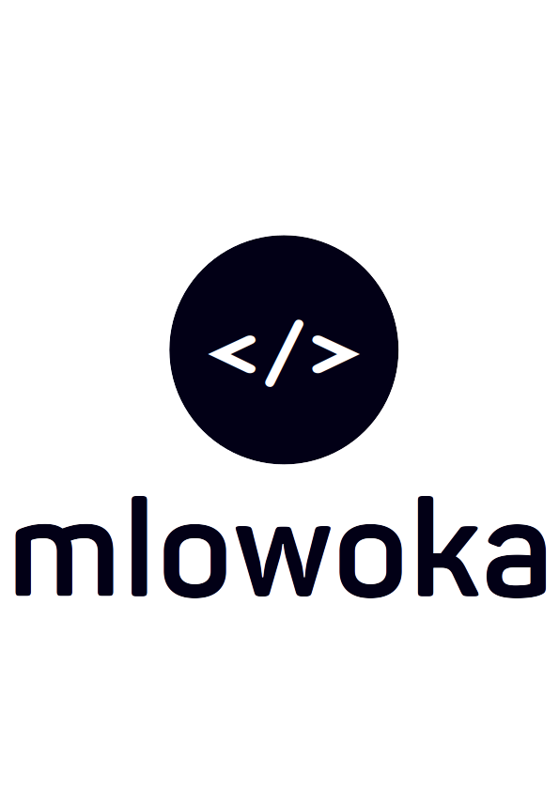
MCOMAT SYSTEM

MEETING REPORT NO. 1001 ON MEMO NO. 1001

The Managing Director  Mzimba College of Management & Technology  P.O Box 40  Mzimba | John Kabatika Chirwa (King Mlowoka)  kingmlowoka16@outlook.com  (+265) 881 88 94 87

Dear Sir
REPORT ON SCRUM MEETING

On the night of the 30th of January 2024, a meeting request to be conducted on the 31st January 2024, was submitted to the administrator of which the aim was to establish a set of delegations in the newly to be developed MCOMAT system. The meeting failed due to my (King Mlowoka) absence at the institution and hence was shifted to 1st February of which we conducted the meeting and agreed upon the following delegations grouped according to office/user:

Note: The every user shown below is the collection of every task that every user will use. For example, an admin can view program syllabus because the admin inherits all the characteristics/tasks of every user despite having specific one listed under the admin section.

The system contains two exams data. The MCOMAT exams and the Board Exams. The MCOMAT exams include both optional lecture continuous tests and mid term exams from the authorized by the Dean of academics office. The Board exams are those that the board assigns to students and grade them including papers that are taken at the end of the semester.

- Every User
  - Log In
  - View Program Syllabus
  - View Course Syllabus
  - Produce Program Syllabus
  - Produce Course Syllabus
  - Update Personal Details
  - Change Password
  - Log Out
- Student
  - View Grades
- Lecture
  - Create, View, Update and Delete a MCOMAT Exam Student Grade
  - View Allocated Courses
- Registrar
  - Create, View, Update and Delete an intake
  - Create, View, Update and Delete a student to an intake
  - Create, View, Update and Delete block
  - Create, View, Update and Delete room
  - View Student OTP
  - View Program(s)
  - Update Student
  - Reset Student Password
  - Reset Intake System Access Token
- Dean of Academics
  - Create, View, Update and Delete Board
  - Create, View, Update and Delete Board Criteria
  - Create, View, Update and Delete Program
  - Create, View, Update and Delete Course
  - Create, View, Update and Delete Study Mode
  - Create, View, Update and Delete Course Outcomes
  - Create, View, Update and Delete Course References
  - Create, View, Update and Delete Level
  - Create, View, Update and Delete Course Indicative Content
  - Create, View, Update and Delete Student Board Grades
  - Allocate Course Teaching Time
  - Assign Program Study Mode
  - Assign Program Board
  - Assign Course Level
  - Assign Course Outcomes
  - Assign Course Indicative Content
  - Assign Course References
  - Assign Lecture to Course
  - Auto-generate Teaching Timetable
  - Allocate Course Teaching Time
  - Auto-generate MCOMAT Exam Timetable
  - Allocate Course Exam Time
  - Allocate Board Exam Timetable
- Admin
  - Create, View, Update and Delete Employee
  - Create, View, Update and Delete Role
  - View All System Users
  - Assign Employee Roles
  - Update Student Access Token

The above are the tasks discussed on the 1st February 2024. These specifications are amendments and improvements of which will be notified in advance and reported after conduction.

Regards
John Kabatika Chirwa
(Software Engineer)

CC: Registrar
Dean of Academics
Administrator

